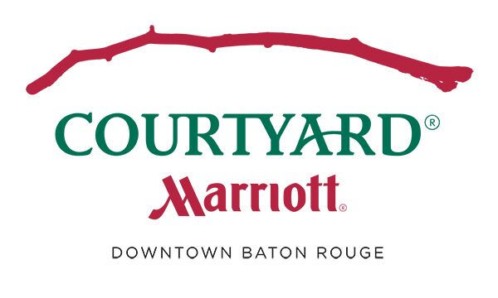
PRESS RELEASE

CONTACT: Ben Blackwell Allison Crump
General Manager Director of Sales
ben@hospitalityamerica.com a.crump@hospitalityamerica.com

COURTYARD HOTEL OPEN IN DOWNTOWN BATON ROUGE
Innovative design and flexible space tailors to the needs of today’s travelers
Baton Rouge, LA – January 22, 2019 – Courtyard by Marriott Baton Rouge Downtown opened its doors in Baton Rouge, Louisiana on Friday September 28th. Featuring an innovative lobby space as well as Courtyard’s latest contemporary room design, the new hotel provides flexibility and choices that allow guests to optimize and elevate their travel experience.
Located at the iconic corner of Florida and Third Street just blocks from the mighty Mississippi River, the 135-room hotel located at 260 3rd Street will operate as a Marriott franchise. The hotel is owned by Istrouma Hospitality, LLC, developed by Windsor Aughtry of Greenville, South Carolina and managed by Hospitality America, LLC of Brentwood, Tennessee.
Whether traveling for business or pleasure, the Courtyard Baton Rouge Downtown is in the epicenter of Downtown Baton Rouge surrounded by many restaurants and attractions. In close proximity, you will find the Louisiana Arts & Science Museum, the Pennington Planetarium, Capital Park Museum, Old State Capital, Shaw Center for the Arts and Science, Manship Theater and the LSU Museum of the Art. The hotel is also the perfect location for visiting your LSU Student or attending your favorite collegiate sporting event. We are located 3 miles from Louisiana State University, Alex Box Stadium and Death Valley. The hotel offers 48 well-appointed balcony rooms with dramatic views of the city, ideal during the Mardi Gras parade season, 4th of July, New Year’s Eve or to just enjoy the scenic views of downtown Baton Rouge. Other hotel features include a 9x9 video wall in the bar to watch your favorite sporting event, valet parking service to greet you upon arrival and a large 24-hour fitness center.
Courtyard constantly researches trends and evolves to meet the changing needs of its guests. The latest room design offers hybrid zones for working, sleeping, relaxing and getting ready. Indirect lighting and a neutral, tone-on-tone color palette makes for a soothing and calm environment. “From day one, Courtyard has prided itself as a brand that listens to business travelers,” said Callette Nielsen, vice president and global brand manager, Courtyard. “Today’s technology has changed how people travel. Our guests want a room that has purpose and flexibility that enables a seamless transition between relaxing and working. Courtyard is designed to offer them a relaxing and functional space to work the way they want to, when they want to.”
The new room design is intuitive and thoughtful, offering flexible yet comfortable spaces that enable technology. Upon arrival, guests can store bags on the “Luggage Drop” and plug personal devices into the “Tech Drop” ledge for seamless technology integration.
Signature furniture and architectural elements replace traditional art in the new guestroom. The “Lounge Around” sofa offers a pop of color and a comfortable area for relaxing or for working. The new design also features a light desk on wheels, allowing guests to work from anywhere in the room.
An upgraded, more spacious layout creates an enhanced bathroom experience. A “Shower Nook” housing shampoos and towels, makes amenities accessible without having to leave the shower.
The Courtyard Baton Rouge Downtown also offers the Refreshing Business lobby environment, where guests can enjoy an open and bright area outside of their rooms. Along with media pods, complimentary Wi-Fi and a variety of seating zones, the redefined space is ideal for everything from pop-up meetings to social gatherings. The lobby also features The Bistro, the nation’s largest chain restaurant, and offers casual, flexible seating; easy access to food and high quality, healthy menu options for breakfast; and light evening fare, including snacks, cocktails, wine and local beer so guests can unwind.
The eight-story hotel sits on the site of the first hotel in downtown Baton Rouge, the Hotel Istrouma, and pays homage to the former hotel in some of its artwork and décor. The new property offers 960 square feet of meeting space to accommodate functions of up to 50 people as well as a fitness center and guest laundry. Additionally, the site brings the first Starbucks to downtown Baton Rouge. The coffee shop is located on the ground floor of the hotel and faces Historic Third Street. The entrance area on Third Street has transformed into a patio with fountains, tables and chairs for patrons to enjoy.
About Courtyard by Marriott
Courtyard by Marriott offers a refreshing environment that helps guests stay connected, productive and balanced. Intuitive services and design accommodate guests’ needs for choice and control. With more than 1,100 locations in nearly 50 countries and territories, Courtyard is proud to participate in the industry’s award-winning loyalty program, Marriott Rewards® which includes The Ritz-Carlton Rewards®. For more information or reservations, visit http://www.courtyardbatonrougedowntown.com, become a fan on Facebook or follow on Instagram.

